Setting Up Jira

- Visit: https://www.atlassian.com/software/jira
- Choose Software Development (1st option)
  - 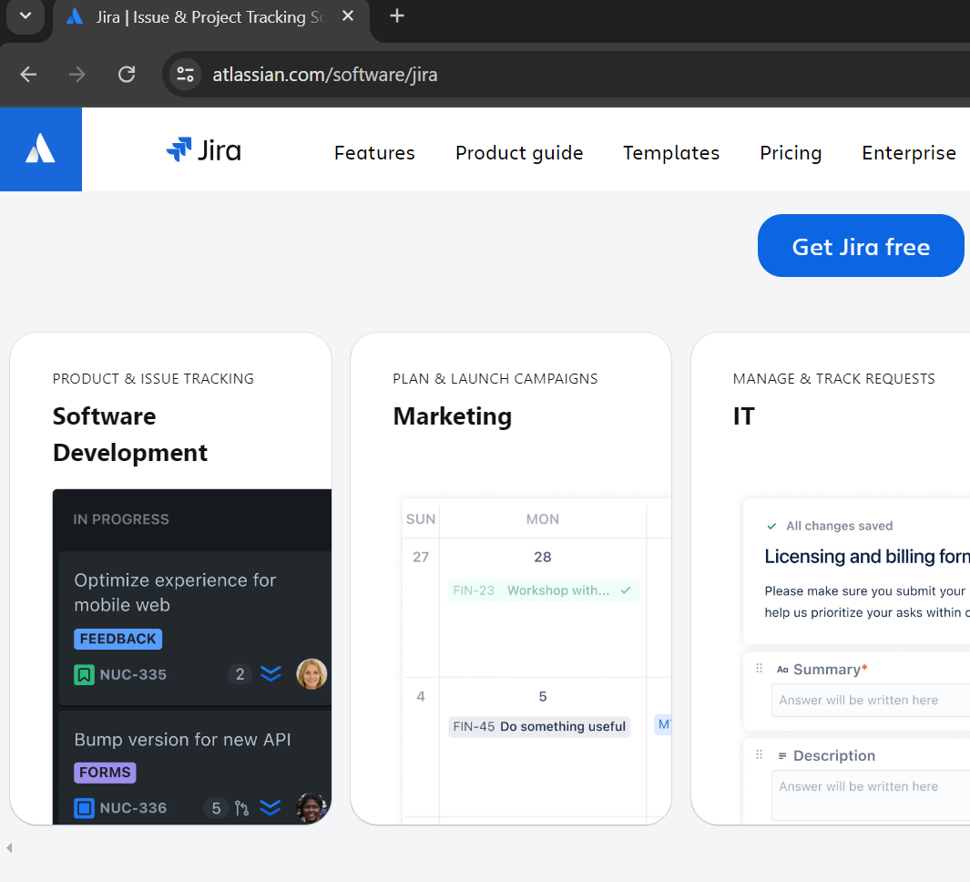
- 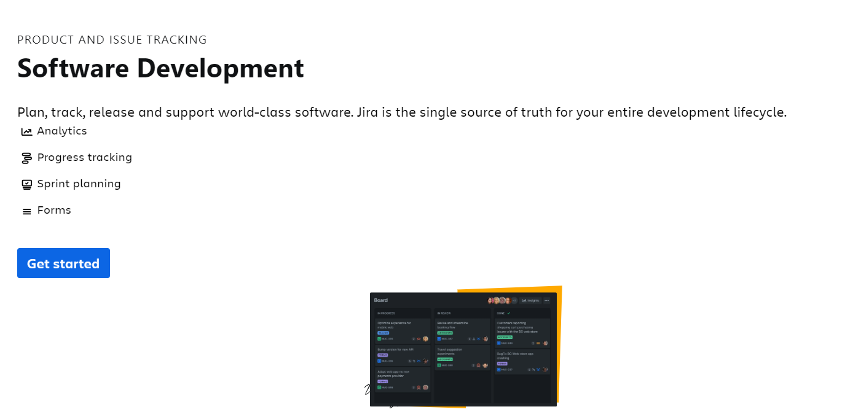
- Use your Personal Gmail account for creating
  - 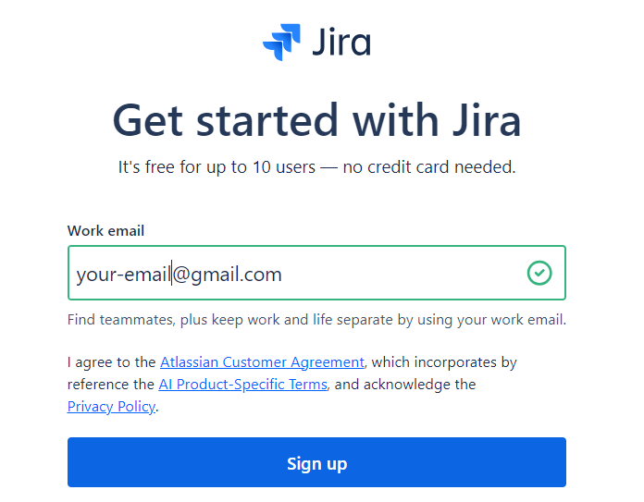
- Create account
  - 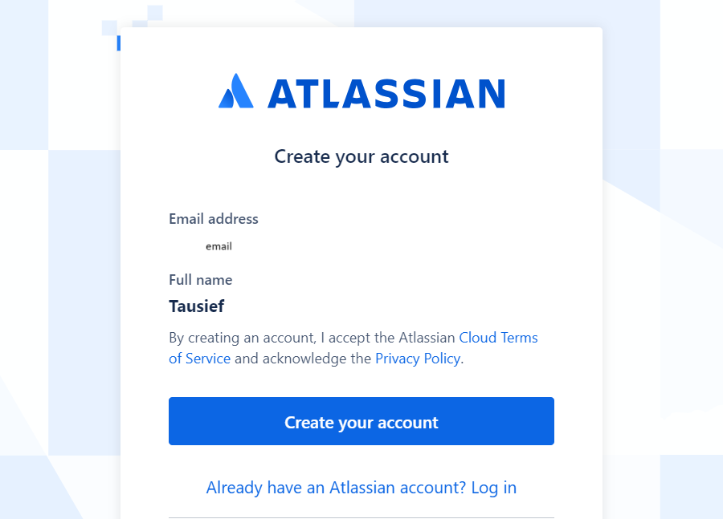
- Choose some unique name for your url / jira setup
  - 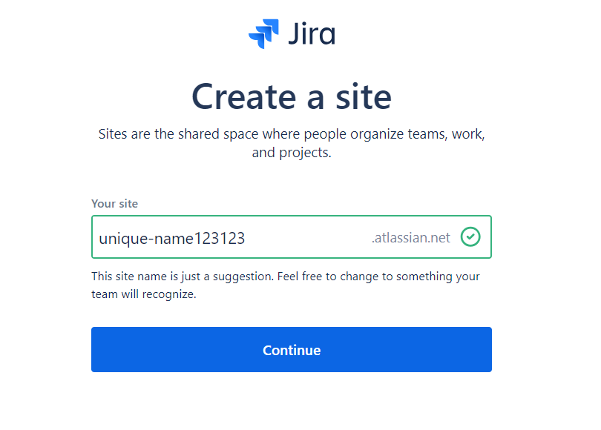
- Choose SCRUM
  - 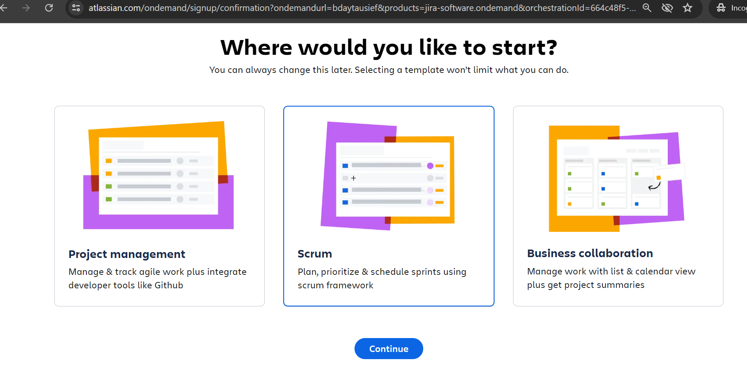
- Setups Your Basic Jira for experimenting:
  - 